**What Does it Take to Win Big in the NBA?**

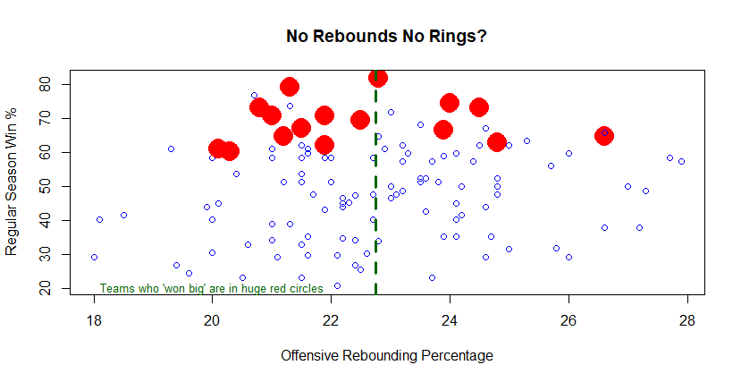

**Disproving Myths: What Winning Big does NOT Require**

* You’ve asked me if the saying is true, ‘no rebounds, no rings’. It is not. While some championship caliber teams do rebound very well, rebounding very well is certainly not necessary to be a championship caliber team; all those big red dots to the left of the green dashed line were BELOW AVERAGE offensive rebounding teams and they all reached their conference finals.

**Other Key Findings**

* Defensive rebounding is much more correlated with winning games in the regular season and with 'winning big' (ie, getting deep into the playoffs) than is offensive rebounding; but neither is necessary to win big.
* While it makes sense and is backed by data that playing good defense helps you win games, it is not true that you MUST be a great defensive team to win big.
* There are many variables that are correlated with how many games a team will win in the regular season, including how well you shoot, how well you defend shooting, how well you control the ball, how well you steal the ball, etc. But when it comes to winning big, getting deep in the playoffs, one predictor dominates - how well you shoot from the field.

**With More Time I’d like to**

* Focus on the predictive value of these stats (doing proper training/testing/cross-validation), as opposed to just primarily checking correlations.
* Use more stats, such as hustle stats.
* Use more years of data.
* Include player level data.
* Ask you more questions to be sure I get to the heart of what you care about.